Mobile Phone & Electronic Device-Free Policy

At Hodge Hill College, we’re committed to creating a learning environment where every student can thrive. Our young people are growing up in an increasingly complex world, living their lives on and offline. This presents many exciting opportunities - but also academic, emotional and social challenges. Our goal is to promote a focused and distraction-free learning environment whilst encouraging responsible use of technology. To support this, we have introduced a mobile phone policy that incorporates the Yondr programme: http://www.overyondr.com.

We believe that every student deserves the chance to experience a phone-free education. Yondr pouches provide a simple and secure way of supporting this approach across our school. This approach provides a balanced solution, ensuring young people retain possession of their phones while minimising distractions during school hours. The pouch helps foster social interaction, improve focus on learning, and reduce stress associated with phone use, all while maintaining communication for families during travel to and from school.

Student Phone Policy & Guidelines

Our school is a phone-free community. Each student will be assigned a personal Yondr Pouch and they are responsible for bringing it to school daily and keeping it in good working condition. Phones and wearable tech will be secured in the pouch upon arrival and remain there until the end of the school day.

Daily Process
Upon arrival, students will:
- Turn their phone off.
- Place their phone and any wearable technology inside their Yondr pouch and lock it in the presence of school staff.
- Keep the pouched phone with them throughout the school day and store it in their bag.
At the end of the school day, students will unlock their pouch, retrieve their phone and tech, and re-close the pouch to protect the locking mechanism from damage. Pouches must be brought to and from school each day.
Procedures and Sanctions
Late Arrivals/Early Dismissals
Students arriving late or leaving early must pouch or unpouch their phones and wearable tech at the main school reception.
Forgotten Pouches
The student will be able to loan a Yondr pouch from the Ready to Learn Hub. Parents/carers will be contacted and reminded of the procedures. If the pouch is repeatedly forgotten, it will be treated as lost and a £14 will be charged for a replacement. We suggest students keep pouches in their school bags, and they remain locked when they are not in use.

Phone Use During the School Day
If a student is found in possession of a phone outside their pouch on school site, the phone will be confiscated and returned when a parent/guardian picks it up from the school site. Bag searches may be conducted if staff are concerned that a student has a mobile phone on them that hasn’t been placed into their pouch.

Damaged Pouches
Any attempt to tamper with the Yondr system, including use or possession of high-strength magnets will be treated as a serious offence, potentially resulting in a £14, confiscation of the device until collected by a parent, and possible suspension.

If accidental damage occurs, students must report it immediately. If damage is discovered during checks and has not been reported, it may be considered intentional. Students will be provided with guidelines to lock their pouch when they leave school to avoid any accidental damage.

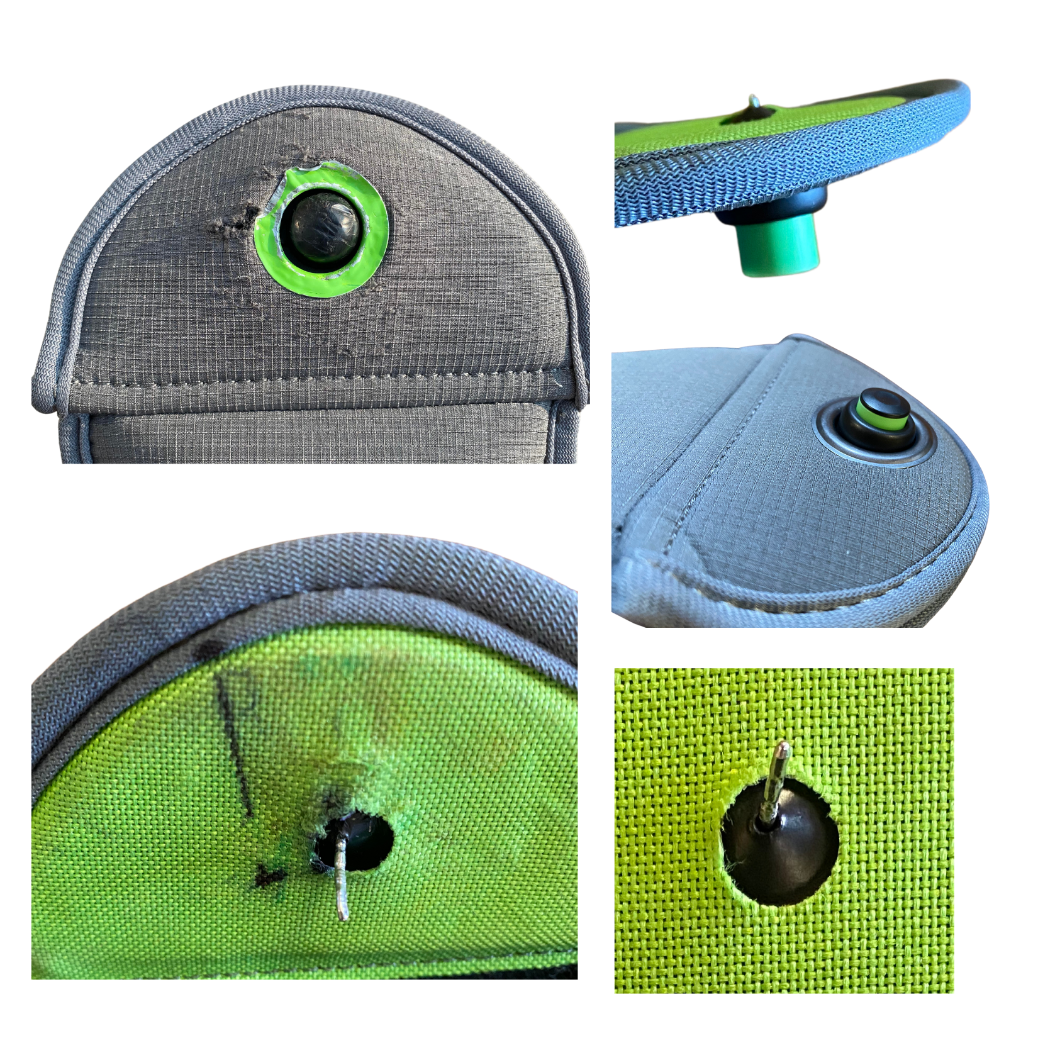
The following may indicate intentional damage:

- Ripped or cut fabric
- Bent or cut pin
- Signs of force to the black locking mechanism
- Pen marks inside the pouch
- Pouch opening without a station
- Scuff marks on the black ball

The pouch should not be used as a replacement for a protective case and/or screen protector on a mobile device.

We will be conducting random pouch/spot checks over the full academic year to assess the condition of the pouches.

Emergencies and Safeguarding
Communications During the School Day
Parents/ carers who need to contact their child during the school day should do so via the school office on 0121 783 7807. We will then pass this message onto your child.

Medical Conditions
Students who require access to their mobile devices for specific medical purposes will be provided with a medical pouch. These medical conditions include but are not limited to: Diabetes type 1, medical impacts and the use of pacemakers.

Emergency Procedures
In an emergency, the priority is for students to follow school safety procedures under staff guidance.
Unauthorised phone use during such situations may:
- Delay emergency responses
- Spread misinformation
- Put students and staff at increased risk
- Disrupt coordinated safeguarding efforts
Emergency communications will be managed through the school.

