Link2ICT Free School Meals Eligibility Checking Service

Parent/Carer User Guide

Link2ICT Free School Meals Eligibility Checking Service

Parent/Carer User Guide

Contents

Introduction 3
Home Page 4
Legal Declaration 5
Application Information 6
Child’s Information 10
Application Submission 12
ECS Return – Found 13
ECS Return – Not Found 14
ECS Return – Service Down 15
Resume Later – Save 16

Introduction

This guide is designed for parent/carers to assist with the online application form to apply for Free School Meal elgibility.
The application form is split into a series of pages. Each of these pages represents a specific area of related data entry, e.g. applicant data; child data etc.
After the home (or launch) page, across the top of each of each page is a series of chevrons, indicating progress towards eventual completion. These chevrons have self-explanatory names:

- Declaration
- Parent/Carer
- Child
- Submit
- End

Data from each completed page will be saved until the applicant decides to either:

- Submit the application
- Save the application details and to return later or
- Cancel the application

Required fields are indicated by an asterisk* after the subsection heading.

The form may be filled in with the Parent/Carer’s authorisation by a member of school staff and if this is the case please note that the values entered should be for the applicant and not the proxy.

Home Page

The Home Page is accessible from any browser at:

www.link2ict.org/fsm

The page that will be seen by the applicant will appear similar to Figure 1 below.

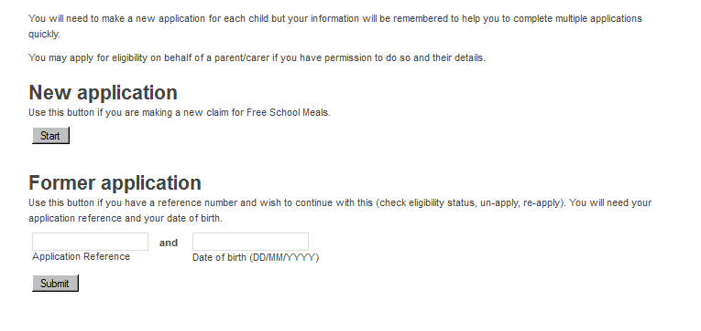

Figure 1
This page gives the applicant the option to start a New application or open a previously completed one (Former application).

New Application

To start a new application, press the [Start] button.

Former Application

To continue with a previously saved application, the applicant will require the 6 character application reference number (previously provided by the system) and the applicant’s date of birth as previously entered on that application. This option will be given for ALL submitted applications regardless of the outcome. Note this is different to a save and resume later option for incomplete applications.

Legal Declaration

The Legal Declaration page will appear similar to Figure 2 below.

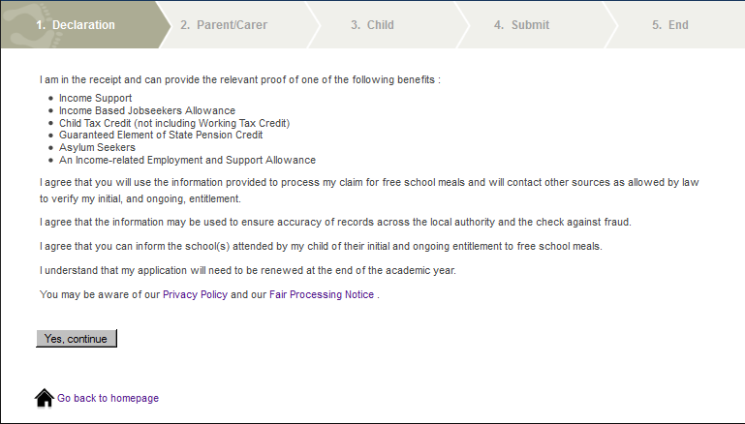
Figure 2
This page contains the detail of the information that is required for the completion of the application and information about the process, security and accuracy of the claim. The page also provides a hyperlinks to our Privacy Policy.

The applicant should press the [Yes, Continue] button to confirm agreement with this declaration and proceed with the application. (If an applicant is unwilling to do this then the application cannot proceed.)

Application Information

Figure 3 below shows the Parent/Carer data entry page.

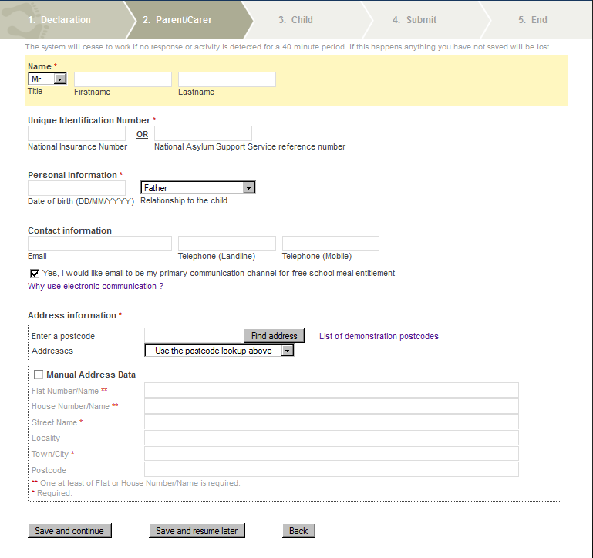
Figure 3

The following lists the data subsections, the fields within each subsection and their data requirements:

Name*

Title | A drop down list is provided which includes all commonly used titles. If the applicants preferred title is not is not in the list then “Other” should be selected and a further box will appear for free text entry.
Firstname | The full given first name of the applicant should be entered - not common contractions.
Lastname | The full legal surname (derived from family, clan or marital association) of the applicant (as written) should be entered.

Note: As the first three characters of this name will be used as a reference by the Eligibility Checking Service (ECS the accuracy of the Lastname field is of critical importance.

Unique Identification Number*

One of National Insurance Number (also known as NI Number or NINO) or National Asylum Support Service reference number (also known as NASS number) must be provided.

Note: As the National Insurance Number, if provided, will be used as a reference by the ECS, the accuracy of this field is of critical importance.

Note: As the National Asylum Support Service reference number, if provided, will be used as a reference by the ECS, the accuracy of this field is of critical importance.

Personal Information*

The following items are required:

Date of Birth | In the format DD/MM/CCYY, where:  DD = Two digit Day (with a leading zero where appropriate)  MM = Two digit Month (with a leading zero where appropriate)  CC = Two digit Century (for current applicants should be 19)  YY = Two digit Year (with a leading zero where appropriate)  For example, the Queen’s birthday would be 21/04/1926.  This field is validated against calendar values.
Relationship to the child | A drop down list is provided listing the government approved list of relationships. (There is an “Other Contact” option but no supplementary box will appear if this value is selected.)
Note: As the applicant’s date of birth will be used as a reference by the ECS, the accuracy of the Date of Birth field is of critical importance.

Contact Information

Email | Email addresses are checked against the standard email address format, i.e. local-part@domain-name.
Telephone (Landline) | The telephone number may be entered in either of two formats:  (a) standard 11 digit UK telephone number format, which will always start with a leading zero, e.g. 02071835700; or  (b) standard international telephone number format, which will always start with a plus-sign, e.g. +442071835700.  As the system does not use this number in any automated process it does not matter if applicants introduce spaces into the number and if the system stores the numbers in this way.
Telephone (Mobile) | The telephone number may be entered in either of two formats:  (a) standard 11 digit UK telephone number format, which will always start with a leading zero, e.g. 02071835700; or  (b) standard international telephone number format, which will always start with a plus-sign, e.g. +442071835700.  It does not matter if applicants introduce spaces into the number.

After the email and telephone data entry boxes there is a tick box which allows the applicant to select Email as the primary communication channel.
Below the tick box is a link which, when clicked, explains some of the advantages of selecting the electronic communication option.

Address Information*

Postcode validation is supplied via Local Land and Property Gazetteer (LLPG) data supplied by BCC. Applicants should enter their postcode in the box provided. The applicant should select the appropriate address from the list. If the postcode is not found, the applicant has two options:

(a) If the applicant is sure that the postcode entered is correct then it is either not within the LA or is a very recent postcode which has not been included in the LLPG. In either of these circumstances, the applicant needs to enter the address data manually – see below; or
(b) The postcode has been entered incorrectly. In this circumstance then the postcode should be re-entered correctly.

Manual Address Entry

If the applicant does not know his/her postcode (or the postcode previously entered was not found) then the address needs to be entered manually. To do this the applicant should click the tick box titled “Manual Address Data”.

The following information should be provided:

At least one (or both) of Flat Number/Name and House Number/Name.

“Flat Number/Name” can be any smaller part of a building, including an apartment or room in a hostel. To avoid confusion the full text should be entered, e.g. “Ground Floor Flat”, “Flat 1”, “Room 101” etc.

“House Number/Name” can include both a number and a name, e.g. “Rose Cottage, 1”. For residents of high-rise blocks, the name of the particular block should be entered here, not in “Flat Number/Name”, e.g. “Washington House”.

Street Name*

A Street Name must be entered. E.g. Orphanage Road

Locality

This is an optional field which may contain extra details such as district or parish area information or, if the postal town is provided (see below), the name of the town or settlement. E.g.: Erdington

Town/City*

The Town/City of the address must be entered. This may be the town or city that is commonly understood in the area or the official postal town (as defined by the Royal Mail). e.g.: Birmingham

Postcode

The postcode, if known, should be provided for those applicants where the postcode was not found or who reside outside of the LA area.

The following validation will be applied.

In general, the format is one of "A9 9AA", "A99 9AA", "A9A 9AA", "AA9 9AA", "AA99 9AA" or "AA9A 9AA", where A is an alphabetic character and 9 is a numeric character.
At the end of this page there are the options to:

Save and Continue | This will save the applicant’s current data and move to the next page of the form.
Save and resume later | This will save the applicant’s current data and create a reference so that he/she can resume their application later.  (See below for resumption of application.)
Back | This will return the applicant to the legal declaration page as indicated by the chevrons across the top of the screen. Data from this screen will be saved until the form is exited.

Child’s Information

Figure 4 shows the data input page for information about the child that the application will affect in relation to the receipt of free school meals.

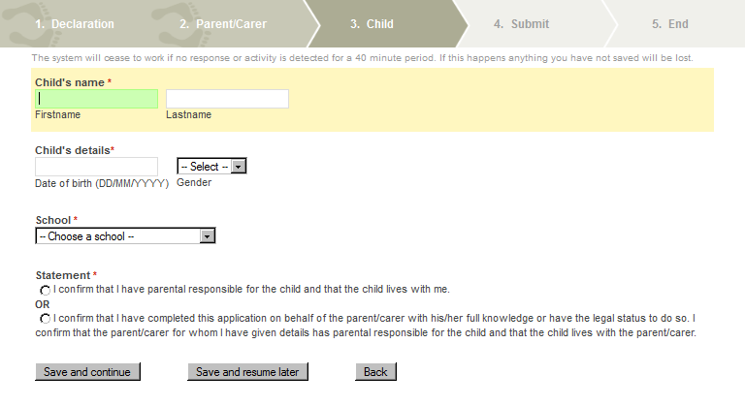
Figure 4
The following lists the fields and their data requirements:

Child’s Name*

Firstname | The full given first name of the child should be entered -not common contractions.
Lastname | The full legal surname (derived from family, clan or marital association) of the child (as written) should be entered.
Child’s Details*

Date of Birth | In the format DD/MM/YYYY. This field is validated against calendar values.
Gender | The sex of the child. (Male or Female)
School*

A pre-defined drop down list is provided. This list includes all schools which have signed up to use the FSM service.
The school that the child attends should be selected - this will be the school where the free school meal will be provided, if eligibility is confirmed.
If the school your child attends is not in the list please contact the school and they will be able to advise what the problem is. If this is the case unfortunately all previously entered data will be deleted.

Statement*

The statement consists of two options, one of which must be selected to confirm the applicant has the legal right to make the application. These options (indicated by radio buttons) are:

I confirm that I have parental responsibility for the child and that the child lives with me.

OR

I confirm that I have completed this application on behalf of the parent/carer with his/her full knowledge or have the legal status to do so. I confirm that the parent/carer for whom I have given details has parental responsibility for the child and that the child lives with the parent/carer.

One of these options must be selected to proceed.

At the bottom of the page there are the options for continuation, indicated by buttons as follows:

Save and Continue | This will save the current data from the application and move to the next page of the form (Submit Application).
Save and resume later | This will save the current data from the application and create a reference so that the application can be resumed in the future. (See below for resumption of application.)
Back | This will return the applicant to the previous page as indicated by the chevrons across the top of the form. Data from this screen will be saved until the form is exited.

Application Submission

Figure 5 shows the submit application page:

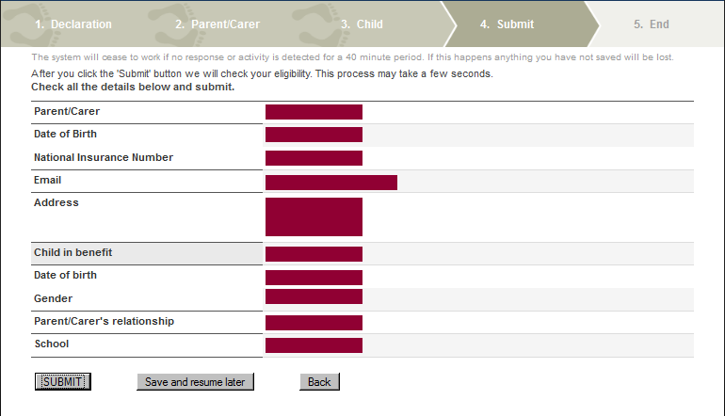
Figure 5
This page is a review of the data that has been captured on the previous pages.

At the bottom of the page there are 3 options:

SUBMIT | This will save the current data from the application and submit it to the ECS for checking.
Save and resume later | This will save the current data from the application and create a reference so that the application can be resumed in the future.
Back | This will return the applicant to the previous page as indicated by the chevrons across the top of the form. Data from this screen will be saved until the form is exited.
After submission to the ECS there are three possible outcomes:

Found | The ECS has confirmed the eligibility to free school meals.
Not Found | The ECS has not confirmed the eligibility to free school meals.
Service Down | The ECS is unavailable at the current time.
These outcomes are described in more detail in the next three sections.

ECS Return – Found

Figure 6 shows the screen which will appear if the ECS has returned a “Found” result:

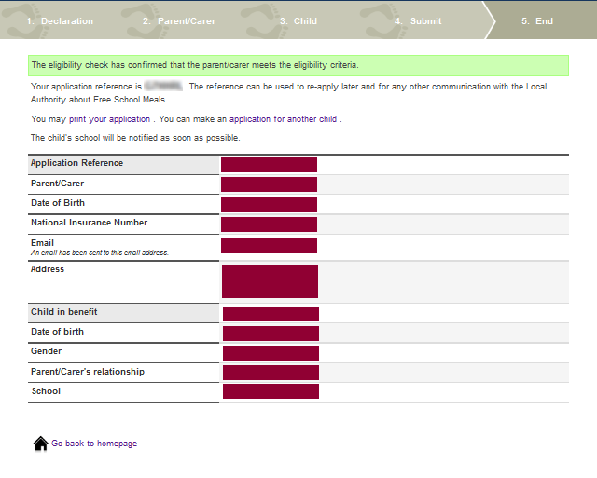
Figure 6

This confirms that the applicant is eligible to claim for free school meals for their child. The applicant should make a note of the application reference and the school and the LA will be notified automatically of the outcome.

A free school meal can be provided for the child as soon as is practicable by the school.

If the Parent/Carer has another child at the same or another school that is signed up for the Link2ICT FSM Service, they can click on the link to make an “application for another child”. This will return the user to the Child’s Information screen on page 11.

ECS Return – Not Found

Figure 7 shows the screen which will appear if the ECS has returned a “Not Found” result:

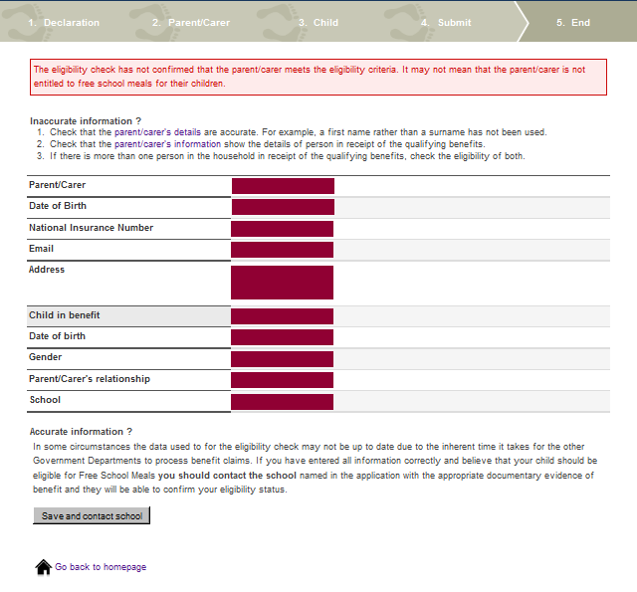
Figure 7
The ECS has NOT found data that would confirm that the applicant is eligible to claim for free school meals for their child. The application will be held by the school for further checking if eligibility systems are updated.

The applicant should make a note of the application reference and if they wish to dispute this outcome they should contact their child’s school as appropriate. When contacting schools, applicants should quote the reference number given and present original copies of any supporting evidence. If the school, having seen the physical evidence, agree that the application should be deemed eligible, they will be able to process this and confirm eligibility.

ECS Return – Service Down
Figure 8 shows the screen which will appear if the ECS has returned a “Not Found” result:

If the ECS is unavailable at the time of submission the following screen will appear:

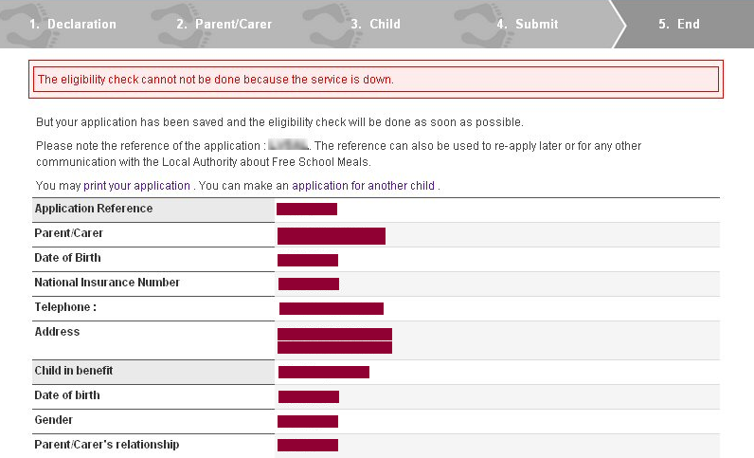
Figure 8
The ECS may not be functioning due to essential maintenance being carried out. If this screen appears the applicant should take a note of the application reference number.

Applications will be automatically resubmitted when the ECS becomes available and the Parent/Carer (and school) informed of the outcome.

Resume Later – Save
Figure 9 shows the screen which will appear if the ECS has returned a “Not Found” result:

If at, any point during the application, the applicant selects to “Save and resume later” then the following will appear:

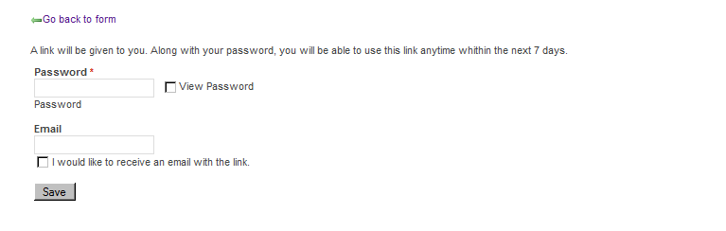
Figure 9
The applicant will be asked to supply a password and, if they wish to be emailed the link, an email address and a check box to confirm this. After clicking [Save] Figure 10 below will appear 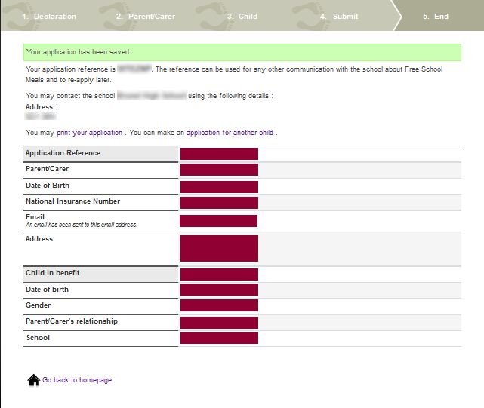
Figure 10

